

**Curriculum Vitae**

Ahmed Mahfouz Mohamed Mostafa Abd el Gowad

**22 Kamal Hewedy st. Khatem El Morsalen, Omrania, Giza**

***Personal Data***

**Phone No.** : 0235624885/ 0.235460355

**Cell No.** : 01000564522

**Nationality** : Egyptian

**Religion** : Muslim

**Marital Status** : Married

**Children** : one (girl)

**Gender** : Male

**Date of Birth** : 14th Jun., 1987

**Email** : [ahmedian_1@hotmail.com](mailto:drilling@ganope.com)

**Military Service** : Exempted

***Education***

**University** : Hewlan University.

**Faculty** : Mattaria Faculty of Engineering

**Major** : Mechanical Power Department Engineering.

**Graduation Grade** : Good.

**Graduation Year** : 2010.

**Graduation Project** : Excellent.

**Project**  : Packing of painting tins

**Master degree** : 2016 (M.Sc.)

**Specialty** : Mechanical Power Engineering

**Master thesis name** : Study of combustion characteristics of waste cooking oil.

**Qualification of Ph.D degree**: Success with grade B+.

**\*Preparing now for Ph.D study at Mechanical Power Engineering.**

***Training Courses***

* Aug. 2010 : ICDL (International Computer Driving license).
* March, 2010 : PLC (Program Logic Control)
* TOEFL 2014 : score 550.
* Role of occupational safety and health : NRC 2017

***Languages***

***Writing, Reading & Speaking*** Arabic : Fluent (Mother Language).

English : Excellent.

French : Pass.

***Computer Skills***

***Operation of Microsoft Office*** : (Word, Access, Excel & Power Point).

***General***  : (Windows XP, Vista & 7, AutoCad, Inventor)

**Engineering Drawing** :( Sigma plot, Grapher, Solid Works, Smart draw, Google sketchup).

***Training***

**Refrigeration and Air condition in National Research Centre:**

13/7/2008 to 31/7/2008

**Refrigeration and Air condition in UNIONAIRE company** 1/11/2010 to 3/3/2014

**Mechanical Design in Eastern Company:** 18/7/2007 to 9/10/2007

***Experience***

**NRC (National Research Centre):** working as mechanical Engineer member of research team 2010 with contract 2 years.

**ITC (international trading centre):** working in maintenances in air conditioning UNIONAIRE CO. (4 years)

**NRC (National Research Centre):** Research assistant at mechanical power department from 2014 till 2016.

**NRC (National Research Centre):** Assistant Research at mechanical power department from 2016 till now.

**NRC (National Research Centre):** Member of the Occupational Safety and Health

Inspection Committee.

***Graduation Project***

**Graduation Project 2010: (with Excellent degree)**

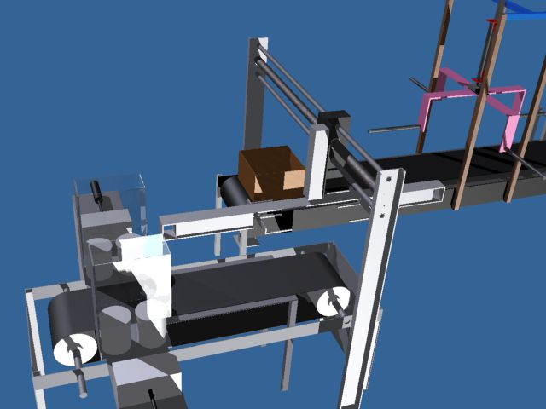 **We have achieved new method for packaging of tins in which these tins are taken from belt and put in the box. This box will be closed to be introduced safely to consumer or storage place. This mechanism required holder, limit switches, pistons, valves, and PLC programming, rods and bearings. The Grade of this project is Excellent.**

***Publications***

1. Abdelgawad A., Emara A., Gad M.S., Elfatih A., "**combustion characteristics of a swirled burner fueled with waste cooking oil**", Proceedings of the ASME 2015 International Mechanical Engineering Congress and Exposition conference; 2015; November 13-19, 2015, Houston, Texas, volume 6A: Energy IMECE2015-53437, pp.V06AT07A007.
2. Ahmed Mahfouz, Ahmed Emara, M.S.Gad, Ahmed El Fatih “**Effect of Waste Cooking - Diesel Oils Blends on Performance, Emissions and Combustion Characteristics of Industrial Oil Burner**” International Journal for Research in Applied Science & Engineering Technology (IJRASET) ISSN: 2321-9653; Volume 5 Issue IX, September (2017).
3. Ahmed Mahfouz, M.S. Gad, Ahmed El Fatih, Ahmed Emara, “**Comparative study of combustion characteristics and exhaust emissions of waste cooking-diesel oil blends**”,Ain Shams Eng. J. 9 (4) (December 2018) 3123-3134.
4. A. Mahfouz, A. Emara, H.S. Ayoub, A.F. El-Sherif, A. El Fatih, Y.H. Elbashar, **“Comparative spectroscopic study inside turbulent flames of diesel and waste cooking oil using hyper-spectral camera”**. Meas. J. Int. Meas. Confederation (IMEKO) 149, 106989, (2020).
5. A. Mahfouz, A. Emara, M.S. Gad, et al., “**Thermal flame spectroscopy of various diesel fuels and their blends with waste cooking oil through using coaxial burner**”, Egyp. J. Petrol. 28 (2019) 307-313, https://doi.org/10.1016/j.ejpe.2019.08.003.
6. A. Mahfouz, H.A. Moneib, A. El-fatih, A.F. El-Sherif, H.S. Ayoub, A. Emara, “**Comparative study among waste cooking oil blends flame spectroscopy as an alternative fuel through using an industrial burner”**. Renew. Energy (2020). Renewable Energy 159 (2020) 893-907 <https://doi.org/10.1016/> j.renene.2020.06.041
7. M.S. Gad, Ahmed Mahfouz, Ahmed Emara, “**Spray and combustion characteristics for light diesel/waste cooking oils blended with fuel additives inside an industrial boiler**”, Fuel, Volume 286, Part 1, 2021, 119247, <https://doi.org/10.1016/j.fuel.2020.119247>.
8. H.A. Moneib, A. Mahfouz, A. El-fatih, Ahmed Emara, “**Near-field Spray Characterization of a Spill Return Atomizer Using a PIV Laser Sheet**”, Fuel, acceptance 14/11/2020.

***Researcher activity***

Reviewer: Energy Conversion and Management journal, Journal of Petroleum Science and Engineering, Egyptian Journal of Petroleum, Journal of the Energy Institute.