**Yomna Osama Abd El Rahman**40 Dar El Hana - Gesr El Suez - Heliopolis  
Cairo, Egypt   
0226388888 / 01011822248  
yomna.osama89@gmail.com

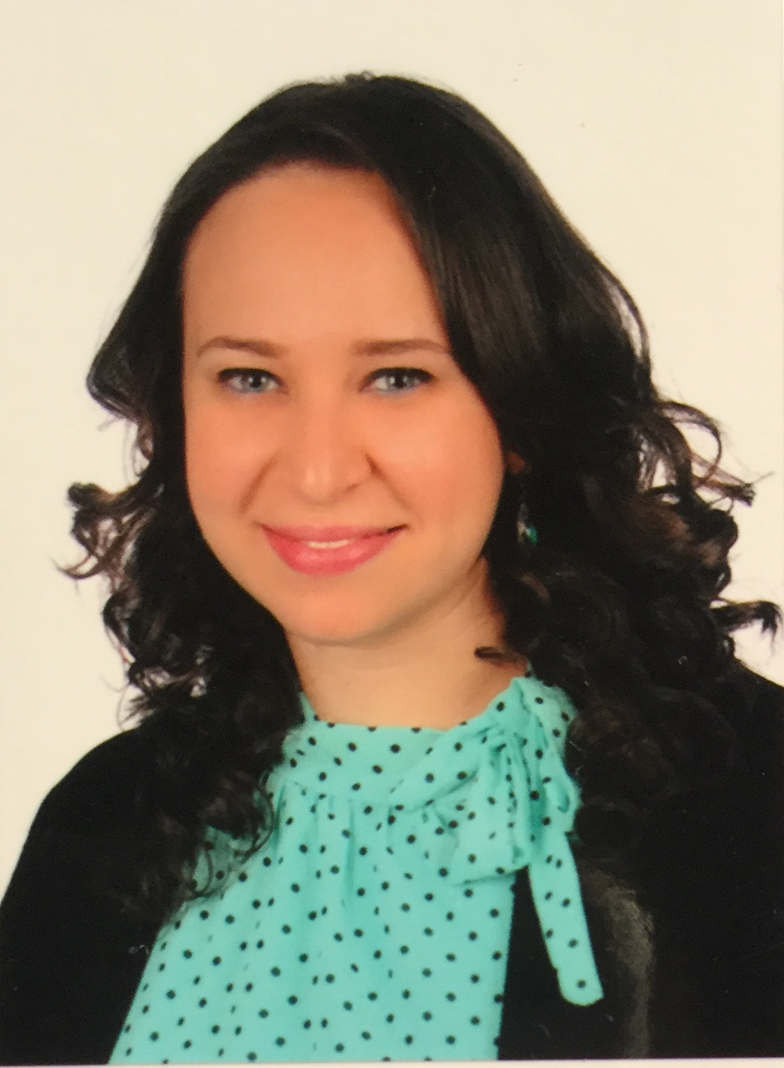

**Date of Birth:** 21/3/1989

**Place of Birth:** London

**Nationality:** Egyptian

**Work Experience:**

* 2014 – present: Research assistant in a project entitled *"Technological and engineering development for production of desalination hollow fiber membranes"* financed by The Islamic Development Bank, Kuwait Development Fund and Academy of Scientific Research and Technology through the Ministry of International Cooperation.
* 2014 – present: Research assistant in National Research Center (NRC), Mechanical Engineering department.
* 2013: 9 months in Arab Organization for Industrialization (AOIin Research and development section
* 2012: 4 months in Green Environment consultants office.

**Education**

* 2017-Present:

PhD courses

* 2012-2016:

Msc. in Materials Engineering

Faculty of Engineering, Ain Shams University

**Master’s Thesis: “**Effect of some Processing Parameters on the Mechanical Properties of Hollow Fiber Membranes”

**Grade:** Excellent

* 2007-2012:

Faculty of Engineering, Ain Shams University  
Materials Engineering, New Programs

Student

Accumulative GPA: **3.66**

**Grade: Excellent**

Rank: **2nd**

Graduation year: August 2012

* Till 2007:

Nefertari International Language Schools

General secondary certificate (98.8%)

**Experience**

* 2016-present: A participant in the Presidential Leadership Program “PLP” in Egypt, second batch
* 2012 (one month): Summer training at Clausthal University in Germany in metals department - multilayer composites.
* 2011: Worked on a project at AUC in nanomaterials department – composite of corn starch with nanoclay particles.
* Summer 2010-2011: 1 month training at Vodafone in Sales department
* Summer 2009-2010: 2 month summer training in polymers lab at faculty of engineering, Ain shams university – natural fibers and polymer composite.
* Summer 2008-2009: a week in Cleopatra for ceramics, summer training.

**Extracurricular Activities**

* 2013: Kids workshop instructor in Meccano workshop
* 2011-2012: Reception head at ACES’12
* 2011: Volunteer in organizing Hamza Namira’s concert with Injaz and Zedny NGOs (14/10/2011)
* 2011: Reception-Public relations member in CATALYSIS (1st new programs based student activity)
* 2010: Children instructor in UCmas.
* 2009-2010: Hosted an event (an opening of an activity in college)
* 2009-2010: Moderator in ACES, the annual conference for engineering students, in RDI “*Research, Development and Innovation”* workshop.
* 2009-2010: HR and PR Advisor in Catalysis, the first new programs based student activity.
* 2008-2009: Participant in MECA academy in *HR* workshop.
* 2008-2009: Participant in ACES, the annual conference for engineering students, in *creativity and innovation* workshop.

**Languages**

* Arabic: Mother language
* English: Fluent – TOEFL iBT (107)
* French: Fair
* **German:** Level 10 at ADK (B2)

**Interests**

* Working in organizations to gain experience in operation system and have a diverse career plan where my skills will be improved
* Continuing my studies (Masters of science and PhD)
* Water treatment, Membranes development, Renewable energy, Biomaterials, Nanotechnology, Solar cells and Composites fields
* Human resources management
* Education development